**Technology Stack**

|  |  |
| --- | --- |
| Date | 31 October 2022 |
| Team ID | PNT2022TMID48018 |
| Project Name | Emerging method for Early Detection of Forest Fires |
| Maximum Marks | 4 Mark |

**Technical Architecture:**

The Deliverable shall include the architectural diagram as below and the information as per the table1 & table 2

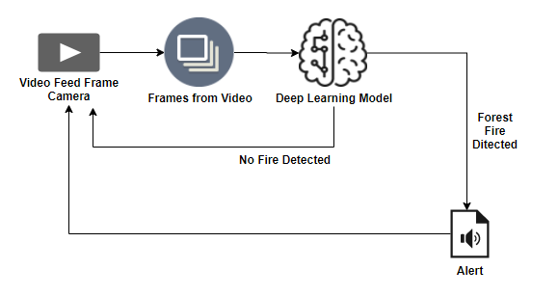

**Table-1 : Components & Technologies:**

|  |  |  |  |
| --- | --- | --- | --- |
| **S.No** | **Component** | **Description** | **Technology** |
| **1.** | User Interface | How user interacts with application e.g. Mobile App, database system | HTML, CSS, JavaScript / Angular Js/ React Js etc |
| **2.** | Application Logic-1 | Logic for a process in the application | Java / Python |
| 3. | Camera | Logic for a process in the application | FPV Camera technology |
| 4. | Smoke sensor | Logic for a process in the application | MQZ, etc |
| 5. | Database | Data Type, Configurations etc. | MySQL, NoSQL, etc. |
| 6. | Cloud Database | Database Service on Cloud | IBM DB2, IBM Cloudant etc. |
| 7. | database system | File storage requirements | Other Storage Service or Local Filesystem |
| 8. | Rotary--wing UAV | Purpose of firefighting used in the application | IBM Weather API, etc. |
| 9. | EFixed--wing UAV | Purpose of weather monitoring.used in the application. | Aadhar API, etc. |
| 10. | Machine Learning Model | Purpose of Machine Learning Model. | Object Recognition Model, etc. |
| 11. | Infrastructure (Server / Cloud) | Application Deployment on Local System / Cloud  Local Server Configuration:  Cloud Server Configuration : | Local, Cloud Foundry, Kubernetes, etc. |

**Table-2: Application Characteristics:**

|  |  |  |  |
| --- | --- | --- | --- |
| S.No | Characteristics | Description | Technology |
| 1. | Open-Source Frameworks | List the open-source frameworks used | Technology of Opensource framework |
| 2. | Security Implementations | List all the security / access controls implemented, use of firewalls etc. | e.g. SHA-256, Encryptions, IAM Controls,OWASP etc. |
| 3. | Scalable Architecture | Justify the scalability of architecture (3 – tier, Micro- services) | Technology used |
| 4. | Availability | ustify the availability of application (e.g. use of load balancers, distributed servers etc.) | Technology used |
| 5. | Performance | Design consideration for the performance of the application (number of requests per sec, use of Cache, use of CDN’s) etc. | Technology used |